Geography Basics
Using the Geography Handbook section of your textbook, answer the following questions on your own sheet of paper.

How do I use maps & globes? What is longitude & latitude?
- To locate places on the Earth, geographers use a system of _________________.
- The Equator & Prime Meridian are two of these imaginary lines that divide the Earth into “half-spheres,” or ________________.
- The ____________divides the Earth into the Northern & Southern hemispheres. The Prime Meridian divides the Earth into ____________________ and ___________________ hemispheres.
- These lines and the other imaginary lines are known as _____________ and longitude. They cross one another forming a pattern called a ________________.
- Lines of latitude are known as ____________________, while lines of longitude are known as _____________.
- What type of line is the Equator? What type of line is the Prime Meridian?
- How is absolute location related to latitude and longitude?
Globes, Maps and Map Projections
- The most accurate way to depict the Earth is by using a ________________. However, ___________ or flat drawings can show small areas in great detail.
- Identify the various types of projections below:
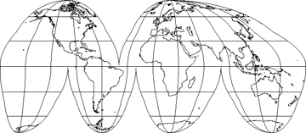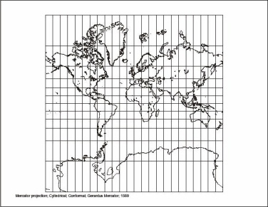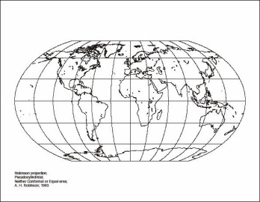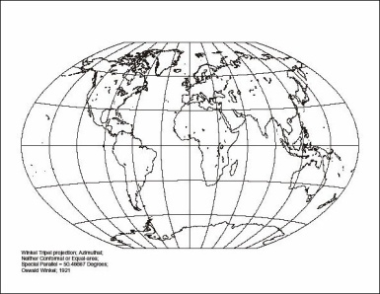
A._____________ B. ___________ C. ___________ D. ___________
- Which type of projection shows the continents the most accurately?
Parts of Maps/Types of Maps
- Define the following: map key, scale bar, compass rose, & cardinal directions.
- Draw a compass rose with both cardinal & intermediate directions.
- List 2 examples of general purpose maps.
- What is the difference between a general-purpose map and a special-purpose map?
- Define physical maps and political maps.
- Physical maps may show _______ or how flat or rugged the land surface is.
- What is elevation and how might this be shown on a physical map?
- Why is a contour map considered a physical map? What does this type of map show?
- Look at the map of Egypt on page 10. What does this map show? Most Egyptians live near which major landform?
Using Graphs, Charts & Diagrams
- What is the purpose of a graph?
- According to the graph on page 11, how many people speak Russian? Which language is least common?
- Create a pictograph displaying the student population at our school. (You may estimate the number of students in each grade.)

