[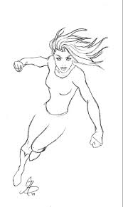](http://www.google.com/imgres?imgurl=http://1.bp.blogspot.com/-5W_g7BlLWkU/TVRizbiAvkI/AAAAAAAACpo/pwp1OlD3fVo/s1600/Woman%252BSuperhero%252B%252525231.png&imgrefurl=http://imgarcade.com/1/superhero-template-drawing/&h=684&w=407&tbnid=xgZwvvyNmp7RqM:&zoom=1&q=super+hero+template&docid=QKt0bPxvJdbsfM&ei=C1gRVY6wGMmcgwS9iYDACQ&tbm=isch&ved=0CGgQMyhBMEE)

[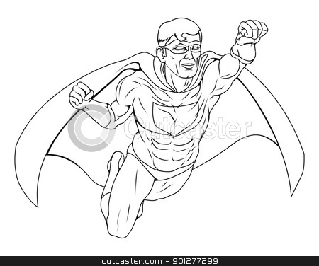](http://www.google.com/url?sa=i&rct=j&q=super+hero+template&source=images&cd=&cad=rja&uact=8&ved=0CAcQjRw&url=http%3A%2F%2Fcutcaster.com%2Fvector%2F901277299-Monochrome-Superhero-Illustration%2F&ei=S1gRVZavLMqrNoCFgdAM&bvm=bv.89184060,d.eXY&psig=AFQjCNFGjrXCqceIBVRInGF0rPX6CvLLCA&ust=1427286411737261)

[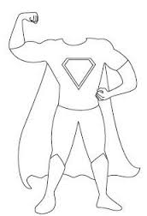](http://www.google.com/imgres?imgurl=https://s-media-cache-ak0.pinimg.com/736x/9a/77/6a/9a776a2393f110638947eb34eb29255e.jpg&imgrefurl=https://www.pinterest.com/vneubauer/super-hero-classroom-theme/&h=316&w=215&tbnid=lobVPxdGkUDEvM:&zoom=1&q=super+hero+template&docid=5ZlOw4_psxyWrM&ei=YlgRVaGoIMubNsWlgqAH&tbm=isch&ved=0CCEQMygEMAQ)

[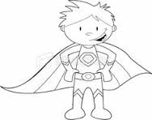](http://www.google.com/imgres?imgurl=https://s-media-cache-ak0.pinimg.com/236x/20/7a/6d/207a6dd74781a8e51607695060213480.jpg&imgrefurl=https://www.pinterest.com/teacher72/super-hero-literacy-month/&h=186&w=236&tbnid=E6qZOXFjRm28nM:&zoom=1&q=super+hero+template&docid=zFSVf0buNqYoYM&ei=YlgRVaGoIMubNsWlgqAH&tbm=isch&ved=0CCkQMygMMAw)

[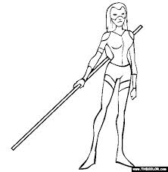](http://www.google.com/imgres?imgurl=http://coloring.thecolor.com/color/images/The%252520Scarlett%252520Mask.gif&imgrefurl=http://imgbuddy.com/superhero-drawing-template.asp&h=565&w=554&tbnid=tx63lFsg9P-uVM:&zoom=1&q=super+hero+template&docid=XR5I4oRImyULkM&ei=YlgRVaGoIMubNsWlgqAH&tbm=isch&ved=0CG0QMyhGMEY)

[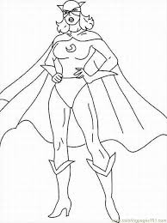](http://www.google.com/imgres?imgurl=http://hellocoloring.com/wp-content/uploads/2014/09/free_printable_coloring_page_superhero_8.jpg&imgrefurl=http://imgarcade.com/1/superhero-template-for-kids/&h=867&w=649&tbnid=yv4Ln3A4szoDYM:&zoom=1&q=super+hero+template&docid=k4sgy7HVBUsG3M&ei=p1gRVbyLIIObgwTYkoH4Bw&tbm=isch&ved=0CEIQMyg6MDo4ZA)

[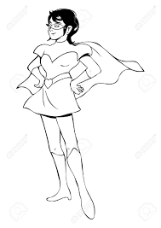](http://www.google.com/imgres?imgurl=http://previews.123rf.com/images/rudall30/rudall301303/rudall30130300004/18473547-outline-illustration-of-a-woman-figure-in-superhero-suit.jpg&imgrefurl=http://imgkid.com/female-superhero-outline-template.shtml&h=1300&w=919&tbnid=5wVeYw58dabDvM:&zoom=1&q=super+hero+template&docid=zdKLsBo2ivHXpM&ei=7VgRVf_8JsiigwSB_4GYCg&tbm=isch&ved=0CBgQMygQMBA4rAI)

[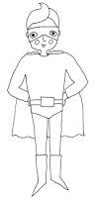](http://www.google.com/imgres?imgurl=http://3.bp.blogspot.com/-gSZwiI5XY4o/UaTSj-S2L5I/AAAAAAAAcVE/uQvTrw2v7GA/s1600/pin100.fathers.download1.jpg&imgrefurl=http://www.hearthandmade.co.uk/2013/06/fathers-day-cards.html&h=1044&w=500&tbnid=ZA6OnxmpwLQyjM:&zoom=1&q=super+hero+template&docid=gmrRaoSYTgSYnM&ei=YlgRVaGoIMubNsWlgqAH&tbm=isch&ved=0CGQQMyg9MD0)