OM Class Shirt Order Forms-$15
*Please, use one form per shirt. If you’d like to order multiple shirts, use separate forms.
Name: ________________________________ Advisory Teacher: ________________
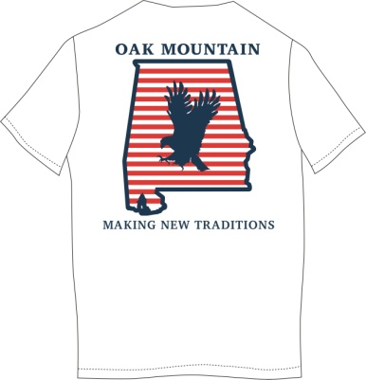
Grade (circle one below):
6 (Navy) 7 (Red) 8 (White)

Shirt Size (circle one below):
Adult Small Adult Medium Adult Large Adult XL

*Shirts will be delivered to Advisory teacher in approximately 2-3 weeks.
FOR SGA USE ONLY: Paid(circle one): CASH or CHECK _____________________ (check number)

OM Class Shirt Order Forms-$15
*Please, use one form per shirt. If you’d like to order multiple shirts, use separate forms.
Name: ________________________________ Advisory Teacher: ________________
Grade (circle one below):
6 (Navy) 7 (Red) 8 (White)

Shirt Size (circle one below):
Adult Small Adult Medium Adult Large Adult XL

*Shirts will be delivered to Advisory teacher in approximately 2-3 weeks.
FOR SGA USE ONLY: Paid(circle one): CASH or CHECK _____________________ (check number)

