Pandora’s Box
Has your curiosity ever got you into trouble? Have you ever been so desperate to know a secret that you took no notice of a warning? All through history there are stories of people being told not to open doors, caskets, cupboards, gates and all sorts of other things and, in so many of the stories, the people just did not listen. One person who did not listen was Pandora. Her story comes from Ancient Greece and her curiosity brought a whole heap of trouble!
In ancient Greece there were two brothers named Epimetheus and Prometheus. They upset the gods and annoyed the most powerful of all Gods, Zeus, in particular. This was not the first time humans had upset Zeus, and once before, as punishment, he had taken from humans the ability to make fire. This meant they could no longer cook their meat and could not keep themselves warm.
However, Prometheus was clever and he knew that, on the Isle of Lemnos, lived Hephaestos, the blacksmith. He had a fire burning to keep his forge hot. Prometheus travelled to Lemnos and stole fire from the blacksmith. Zeus was furious and decided that humans had to be punished once and for all for their lack of respect.
Zeus came up with a very cunning plan to punish the two brothers. With the help of Hephaestos, he created a woman from clay. The goddess Athene then breathed life into the clay, Aphrodite made her very beautiful and Hermes taught her how to be both charming and deceitful. Zeus called her Pandora and sent her as a gift to Epimetheus.
His brother Prometheus had warned him not to accept any gifts from the gods but Epimetheus was completely charmed by the woman and thought Pandora was so beautiful that she could never cause any harm, so he agreed to marry her.
Zeus, pleased that his trap was working, gave Pandora a wedding gift of a beautiful box. There was one very, very important condition however, that she must never opened the box. Pandora was very curious about the contents of the box but she had promised that she would never open it.
All she could think about was; what could be in the box? She could not understand why someone would send her a box if she could not see what was in it. It seemed to make no sense at all to her and she could think of nothing else but of opening the box and unlocking its secrets. This was just what Zeus had planned.
Finally, Pandora could stand it no longer. When she knew Epimetheus was out of sight, she crept up to the box, took the huge key off the high shelf, fitted it carefully into the lock and turned it. But, at the last moment, she felt a pang of guilt, imagined how angry her husband would be and quickly locked the box again without opening the lid and put the key back where she had found it. Three more times she did this until, at last, she knew she had to look inside or she would go completely mad!
She took the key, slid it into the lock and turned it. She took a deep breath, closed her eyes and slowly lifted the lid of the box. She opened her eyes and looked into the box, expecting to see fine silks, gowns or gold bracelets and necklaces or even piles of gold coins.
But there was no gleam of gold or treasure. There were no shining bracelets and not one beautiful dress! The look of excitement on her face quickly turned to one of disappointment and then horror. For Zeus had packed the box full of all the terrible evils he could think of. Out of the box poured disease and poverty. Out came misery, out came death, out came sadness - all shaped like tiny buzzing moths.
The creatures stung Pandora over and over again and she slammed the lid shut. Epimetheus ran into the room to see why she was crying in pain. Pandora could still hear a voice calling to her from the box, pleading with her to be let out. Epimetheus agreed that nothing inside the box could be worse than the horrors that had already been released, so they opened the lid once more.
All that remained in the box was Hope. It fluttered from the box like a beautiful dragonfly, touching the wounds created by the evil creatures, and healing them. Even though Pandora had released pain and suffering upon the world, she had also allowed Hope to follow them. And Hope made all the difference in the world.

Pandora's Box
A poem by Paul Perro
According to old Greek legends
There once was a time when
There were no women in the world,
There were only men.
That is, until the mighty Zeus
Went to see Hephaestus one day,
And ordered him to make
A woman out of clay.
They named the woman Pandora
And breathed her full of life,
Then gave her to a young man named
Epimetheus, as his wife.
But Zeus was not really being nice,
He had a wicked plan.
His enemy Prometheus
Was the brother of the young man.
Zeus gave them a box with a key,
Then he sternly decreed
That they must never look inside.
The young couple agreed.
Now Zeus thought Epimetheus,
Despite this conversation,
Would be unable to withstand
The terrible temptation.
In fact it was Pandora who
Gave in to curiosity.
She quietly crept, as her husband slept,
And from him, took the key.
The box held many nasty things,
Unknown to Pandora,
And all of them could fly, which she
Discovered to her horror.
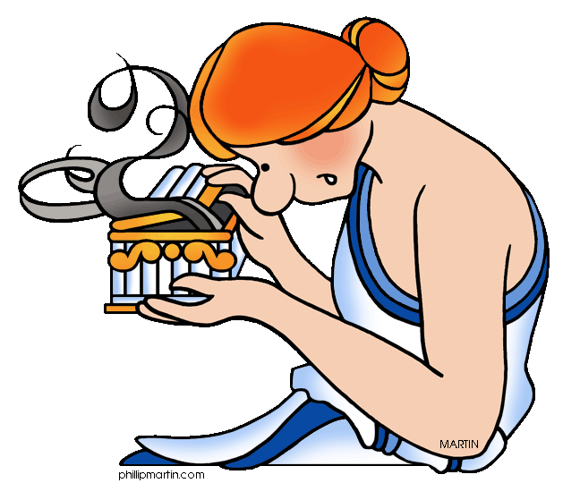 | She unlocked and opened the box  And the first to escape was rage,  Followed by pain, then jealousy,  Disappointment, greed and old age.  Out flew measles, mumps, rubella,  Bubonic plague, chicken pox,  Leprosy, hepatitus B,  All escaped from Pandora's box.
Pandora was shocked and appalled,
What on earth had she done?
Soon all of the things had escaped,
...all, that is, except one.
As she peered into the box,
She slowly became aware,
A little thing called "hope"
Was still trapped in there.
Pandora sighed and let it go.
She knew, if there was hope,
Then no matter what else happened,
The human race could cope.
CCRS RL 6.9 Compare and contrast texts in different forms or genres in terms of their approaches to similar themes and topics. (e.g. stories and poems, historical novels and fantasy stories)
What insight can you gain from the differences of these two texts?
Is the theme apparent in both forms?
As students read a short story, they “doodle,” either in a journal or using an online tool, responding to the text through images, symbols, shapes, and colors. They must be sure to represent all of the elements of the short story (setting, plot, character, point of view, theme) in their doodles. Students then work in small groups, to construct a graphic of their story on a sheet of newsprint with crayons or markers. When all groups have completed their graphics, they will present them to the class, explaining why they chose the elements they used. Finished graphics can be displayed on a class bulletin board, on walls, or scanned in to a Web page.
This online tool combines the process of drawing with analytical thinking by pairing online drawing with writing prompts that encourage students to make connections between their visual designs and the text.

