CHMS FACILITIES UPDATE
Stairs to Be Moved
It is the middle of May and renovation work at Chelsea Middle School is underway. The pictures shown here are of the work being done to enlarge the existing passageway between the new 6th grade wing and the existing middle school. This work will be completed before school starts in August. In brief, the stairs are being moved so that the hallway is large enough to easily handle middle school students moving between the cafeteria and the 6th grade wing.
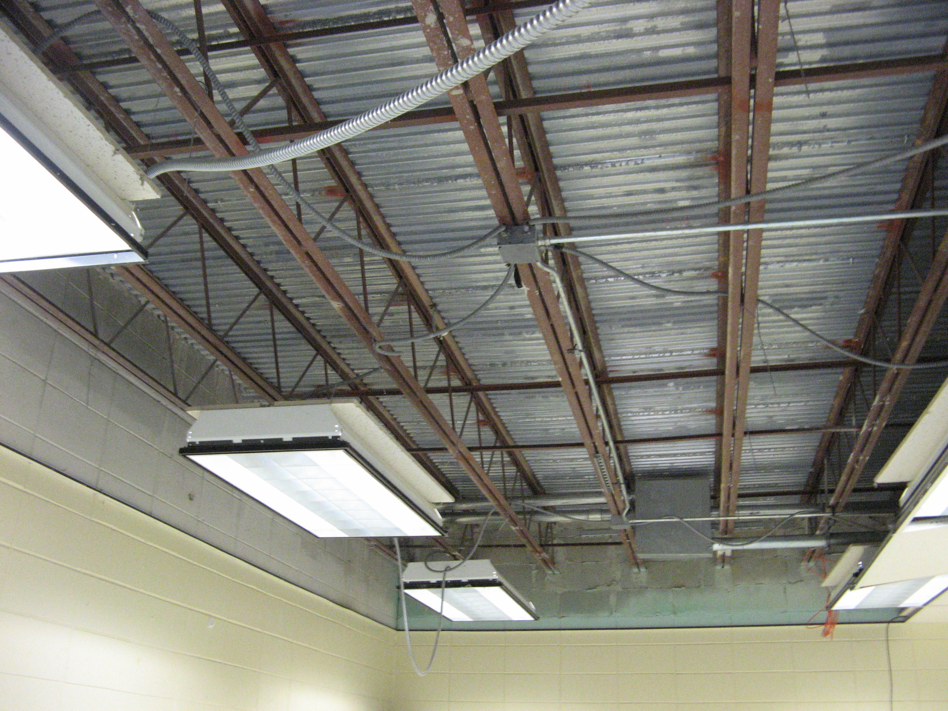

Painting and Cleaning
This week, the former intermediate media center was painted from top to bottom, including the storage and utility rooms on the side. Other rooms and areas will be painted as needed. Over the summer our new classrooms will be cleaned, the floors waxed, and teachers’ materials moved in.
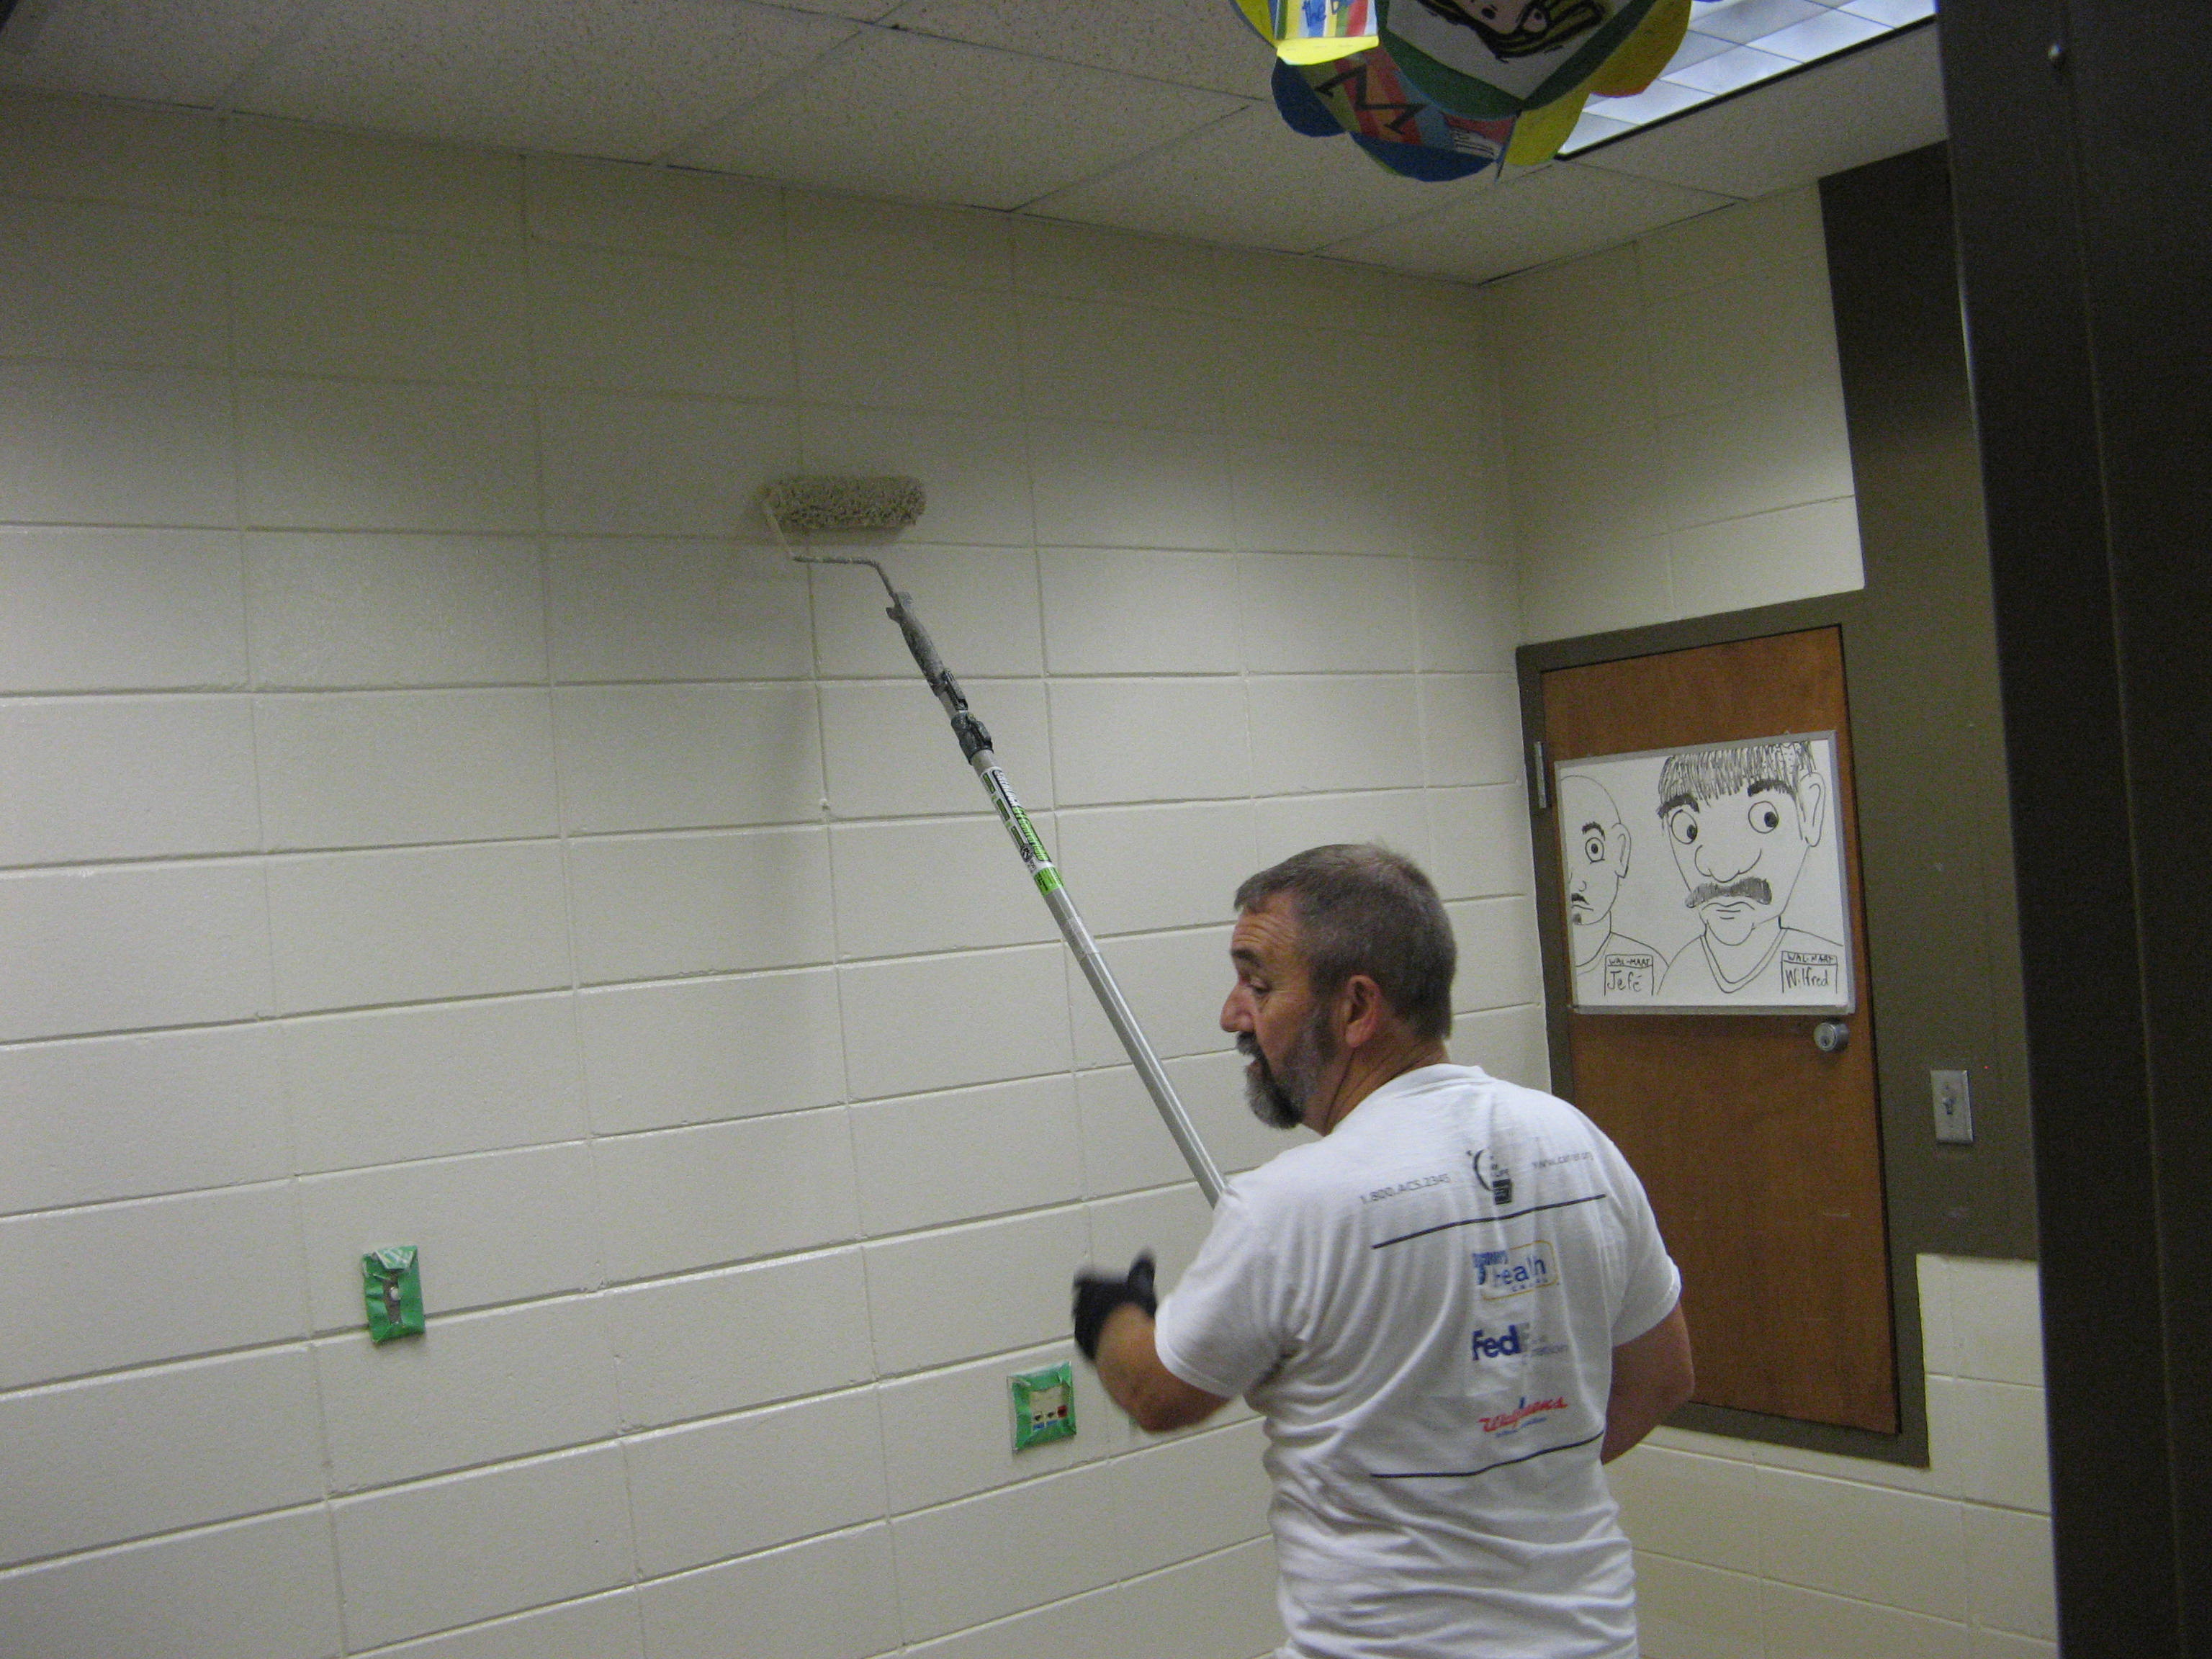
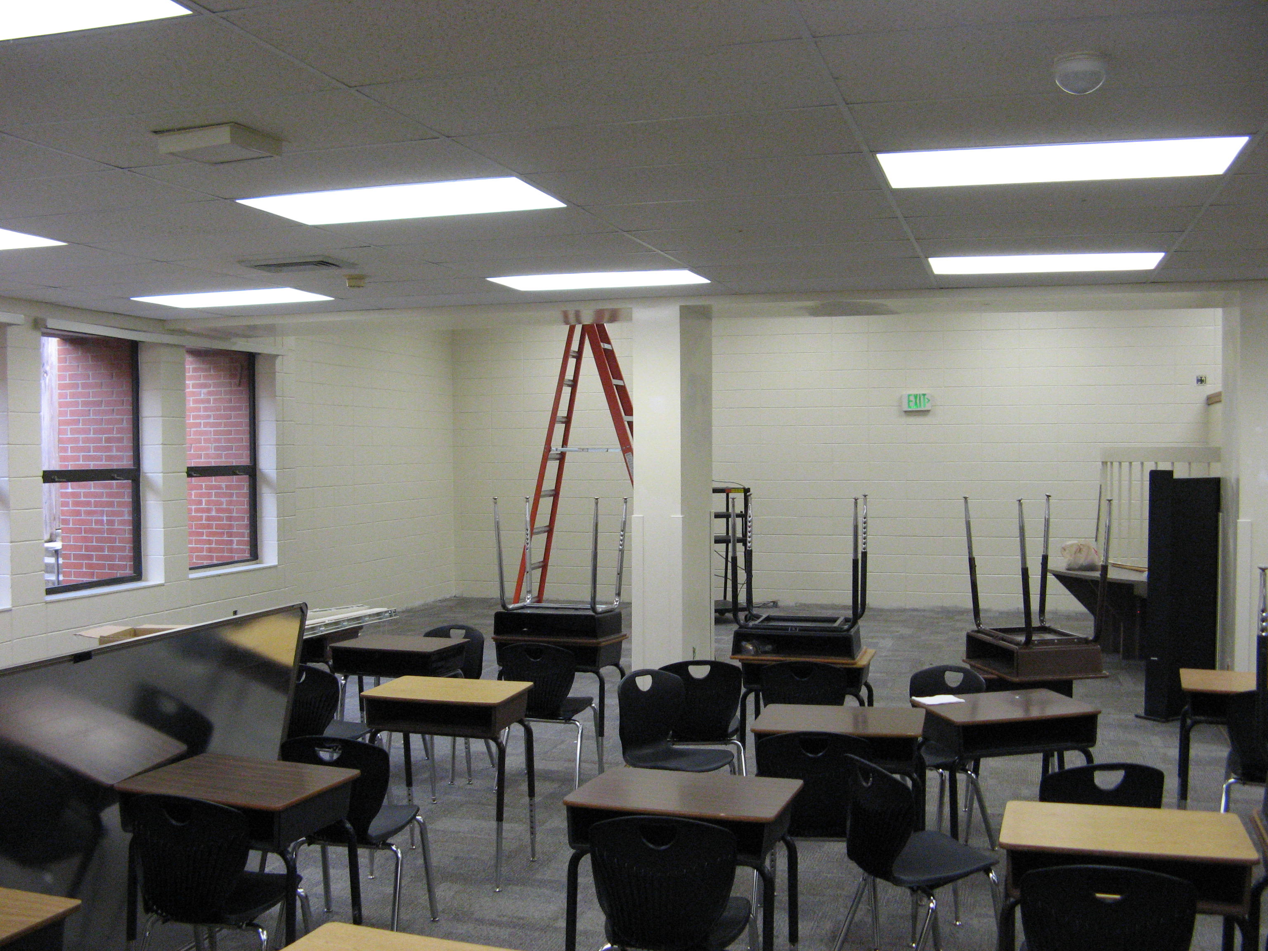

Boxes Needed
We are asking for parents to donate boxes (no larger than 24” x 12”) to help our teachers pack up to store and move their materials. You may bring them to the front office or drop them off with your child at car-rider. Thanks in advance!
Restrooms to Be Renovated
This week representatives of the architectural firm Latham
and Associates studied the restrooms in the 6th grade
hallway and the 8th grade hallway, including faculty restrooms,
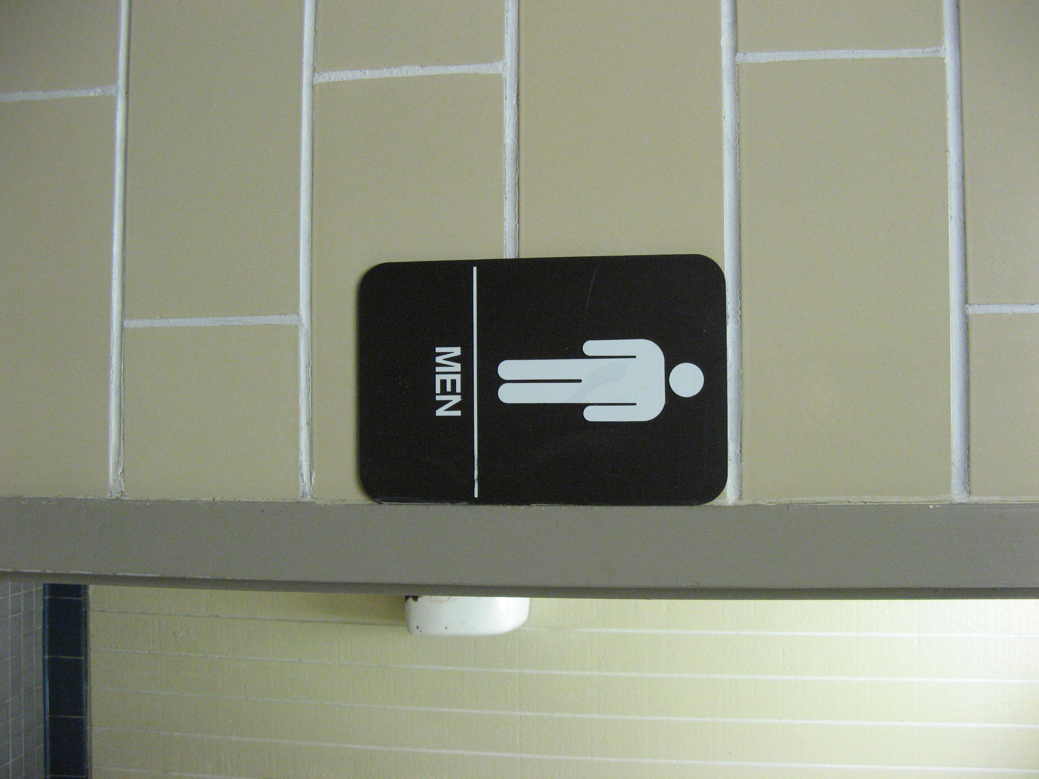
to develop a renovation plan/design. We anticipate this will be
done over the summer.

Future Renovation
We fully expect that major reconstruction will take place next
year, perhaps starting as early as the beginning of school. During reconstruction students will be safe and learning will continue. Obviously normal routines may be disrupted; however the quality education we have always provided will take place. As a team, the architects, central office staff, construction staff and school staff will work together to keep the main thing the main thing: high quality instruction and learning.

Thanks to our PTO

Recently our incredible PTO has continued to support the teachers, students, and staff of CHMS . Their gifts, volunteer copying, food, and beautification of the school have had a positive impact on the climate and mood of the school!

Kelly and Traci reorganize our display case ! Kelly shows off our new flower pots!
