The Brenda Tolbert Williams Scholarship
Phone: 205-400-2834 | Email: latashathomas1913@gmail.com |
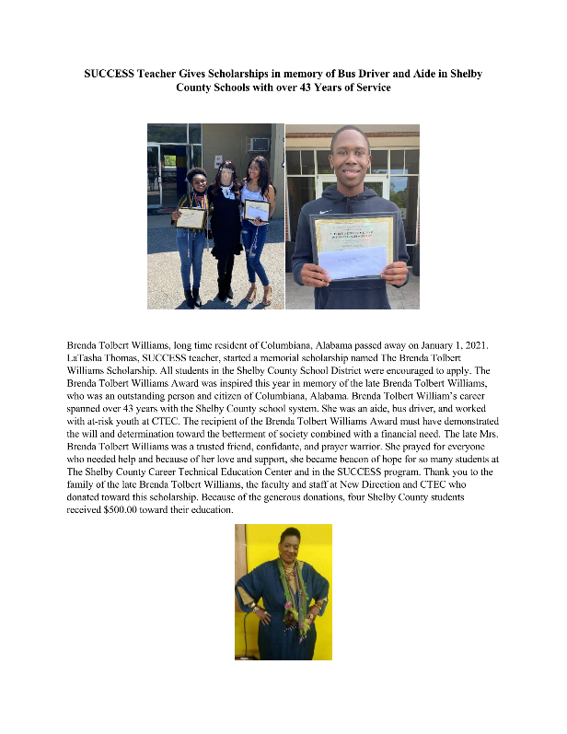

HIGH SCHOOL SCHOLARSHIP APPLICATION
The Brenda Tolbert Williams Scholarship Committee is currently accepting applications for the BTW scholarship from graduating high school seniors attending college for the 2022-2023 school year. Applicants should have the following credentials:
- Graduating high school senior in the Birmingham Metropolitan Area or one of the following counties: Bibb, Blount, Chilton, Jefferson, Shelby, St. Clair and Walker
- Entering college as a freshman Fall 2022 or Spring 2023 term
- GPA of at least 2.5
- ACT Score of at least 16
To be considered for scholarship, applicants must provide the following:
- Complete an application form online
- Provide (1) Academic Letter of Recommendation from a School Official, such as a Teacher, Principal, or Counselor
- Provide a copy of OFFICIAL high school transcript
- Provide a copy of ACT scores
- A head shot photograph for display and media purposes (required)
- Submit a complete application package by March 1, 2022

AWARD NOTIFICATIONS & REQUIREMENTS
Applicants who are awarded scholarships will be notified mid-April 2022 and will be recognized according to your Award’s Program at your school (recipient's attendance required).
APPLICANTS ARE RESPONSIBLE FOR PROVIDING INSTRUCTIONS TO HIGH SCHOOL OFFICIAL AND AGENCY OFFICIAL WRITING LETTERS OF RECOMMENDATION ON THEIR BEHALF.

INSTRUCTIONS FOR APPLICANTS
Applicants must meet minimum eligibility requirements and submit a complete application package to be considered for scholarship awards. Materials submitted online must be received by 11:59 p.m. CST on March 1, 2022. Materials submitted via U.S. mail must be postmarked by March 1, 2022.
□ Scholarship Application completed and submitted online
□ Academic Letter of Recommendation from a School Official, such as a Teacher, Principal, or Counselor submitted online. Recommenders must use their professional email addresses or upload the Letter of Recommendation on School Letterhead.
□ Community Service Letter of Recommendation submitted online. Recommenders must use their professional email addresses or upload the Letter of Recommendation on Agency Letterhead.
□ Submit OFFICIAL high school transcript via U.S. mail
□ Submit ACT scores via U.S. mail
□ Head shot photograph
□ Personal Statement in 250 words or less about you, your educational goals, and how the scholarship will help continue your education.
□ A Media Release Form that is signed completed online. Applicants under the age of 18 should have their Parent/Guardian complete and sign the form online. If applicants are over the age of 18, they should complete and sign the form online.
□ Scholarship Award winners will be recognized at your school’s Award’s Program and are required to attend.
The High School Transcript and ACT Scores should be mailed (postmarked by March 1, 2022) to the following address:
LaTasha Thomas- BTWS Founder
ATTN: Scholarship Committee
CTEC/SUCCESS Program
701 Highway 70
Columbiana, AL 35051
Please click on the appropriate
link

below to access the appropriate form.

Scholarship Application

PLEASE CONTACT THE SCHOLARSHIP COMMITTEE CHAIR AT lthomas@shelbyed.org IF YOU HAVE ANY QUESTIONS.
THE BRENDA TOLBERT WILLIAMS SCHOLARSHIP
Phone: 205-400-2834 | Email: lthomas@shelbyed.org | www.latashathomas1913@gmail.com

LETTER OF RECOMMENDATION FOR SCHOLARSHIP APPLICANT
The Brenda Tolbert Williams Scholarship Fund is currently accepting applications for scholarships from graduating high school seniors attending college for the 2022-2023 school year. Applicants should have the following credentials:
- Graduating high school senior in the Birmingham Metropolitan Area or one of the following counties: Bibb, Blount, Chilton,
Jefferson, Shelby, St. Clair and Walker
- Entering college as a freshman Fall 2022 or Spring 2023 term
- GPA of at least 2.5
- ACT Score of at least 16
- Community Service Involvement
To apply, applicants must provide the following letters of recommendations:
• Academic Letter of Recommendation from a College Official, such as a Teacher, Principal, or Counselor
Applicants are responsible for providing this document to the college official and agency official writing letters of recommendation on their behalf.

INSTRUCTIONS
An applicant has identified you as an individual to submit a Letter of Recommendation on their behalf. Please complete the online form via the link below no later than March 1, 2022 AT 11:59 P.M. CST. To submit letters of recommendations:
- Complete the online form and provide contact information preferably including a professional (i.e. school, company, or agency) e-mail address o If you have a professional email address, submit your Letters of Recommendation online in the appropriate field or by uploading the signed Letter of Recommendation in the designated area in the form.
LETTERS OF RECOMMENDATIONS ARE DUE NO LATER THAN MARCH 1, 2022 AT 11:59 P.M. CST
Please contact the Scholarship Committee Chair at latashathomas1913@gmail.com if you have any questions.

