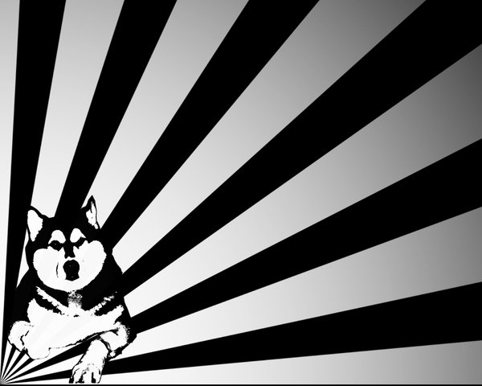
Husky One-Act festival
6 short plays
3 directors
1 awesome afternoon

JAN 22 – 4PM
$3 a ticket

