Theater I is proud to present…
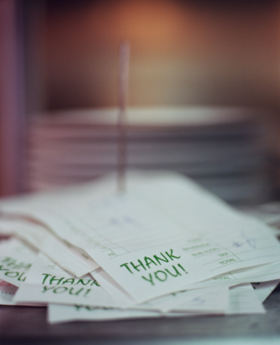

Check Please
By
Jonathan Rand

Jan 20 - 4PM and 5PM - HHS auditorium – 8th & 4th period
Jan 21 – 4PM – HHS auditorium – 2nd period
$3 a ticket

