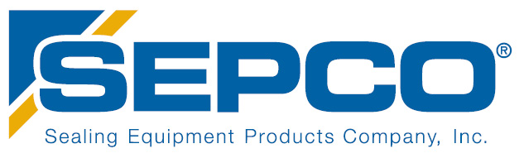

COMPANY SUMMARY

SEPCO is a global sealing solutions provider based in Alabaster, Alabama. With a history of providing quality fluid and dry sealing components, SEPCO manufactures pump and valve packing, mechanical seals, gasket materials, high-performance plastics, air seals, and bearing isolators.

Careers at SEPCO
123 Airpark Industrial Road, Alabaster, AL 35007

Grafoil/Ring Press Operator:

The Grafoil/Ring Press Operator is responsible for producing quality parts/pieces along with performing various other duties, including set up, operate and tend machines that produce Rings to dimensional quality per requirements. Hourly pay starting at $12 with a performance review after 90 days for an increase in pay.

CNC Machinist:

The CNC Machinist will plan machining operation by studying work orders, blue prints, engineering drawings, materials, specification and machining parameters. Machinist are responsible for machining materials to customer specifications. Most work is custom with some small quantity jobs. Programming at the controls is a must. Work is performed in a clean climate-controlled environment. Tools are provided. Day shift (M-F, 7a-3:30p) and night shift (M-Th, 4p-2:30a) positions available. Hourly rate $29 depending on experience.

See full job description including duties and requirements online at www.SEPCO.com. To apply send resume to jeanz@sepco.com.

