Meet the Glands!

**You are to create a “Character” of one of the glands of the endocrine system. The drawing should be colorful and you should include a short informative story about the life of this gland (what it does day to day). The story should be a minimum of 10 sentences and should be written underneath the drawing of the character.**

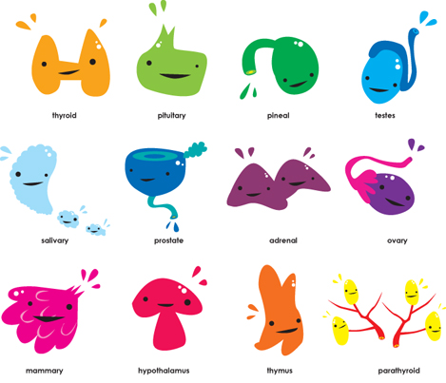

**Example:**

**Hi, I ‘m Tony the thyroid gland. You only have one of me, I live in front of your trachea. I can help you to metabolize the food you eat. Boy am I busy on holidays! All that Food! Etc, etc.**



**Choices:**

**Thyroid**

**Hypothalamus**

**Pituitary Gland**

**Parathyroid**

**Thymus**

**Pancrea**

**Adrenal**

**Ovaries**

**Testes**