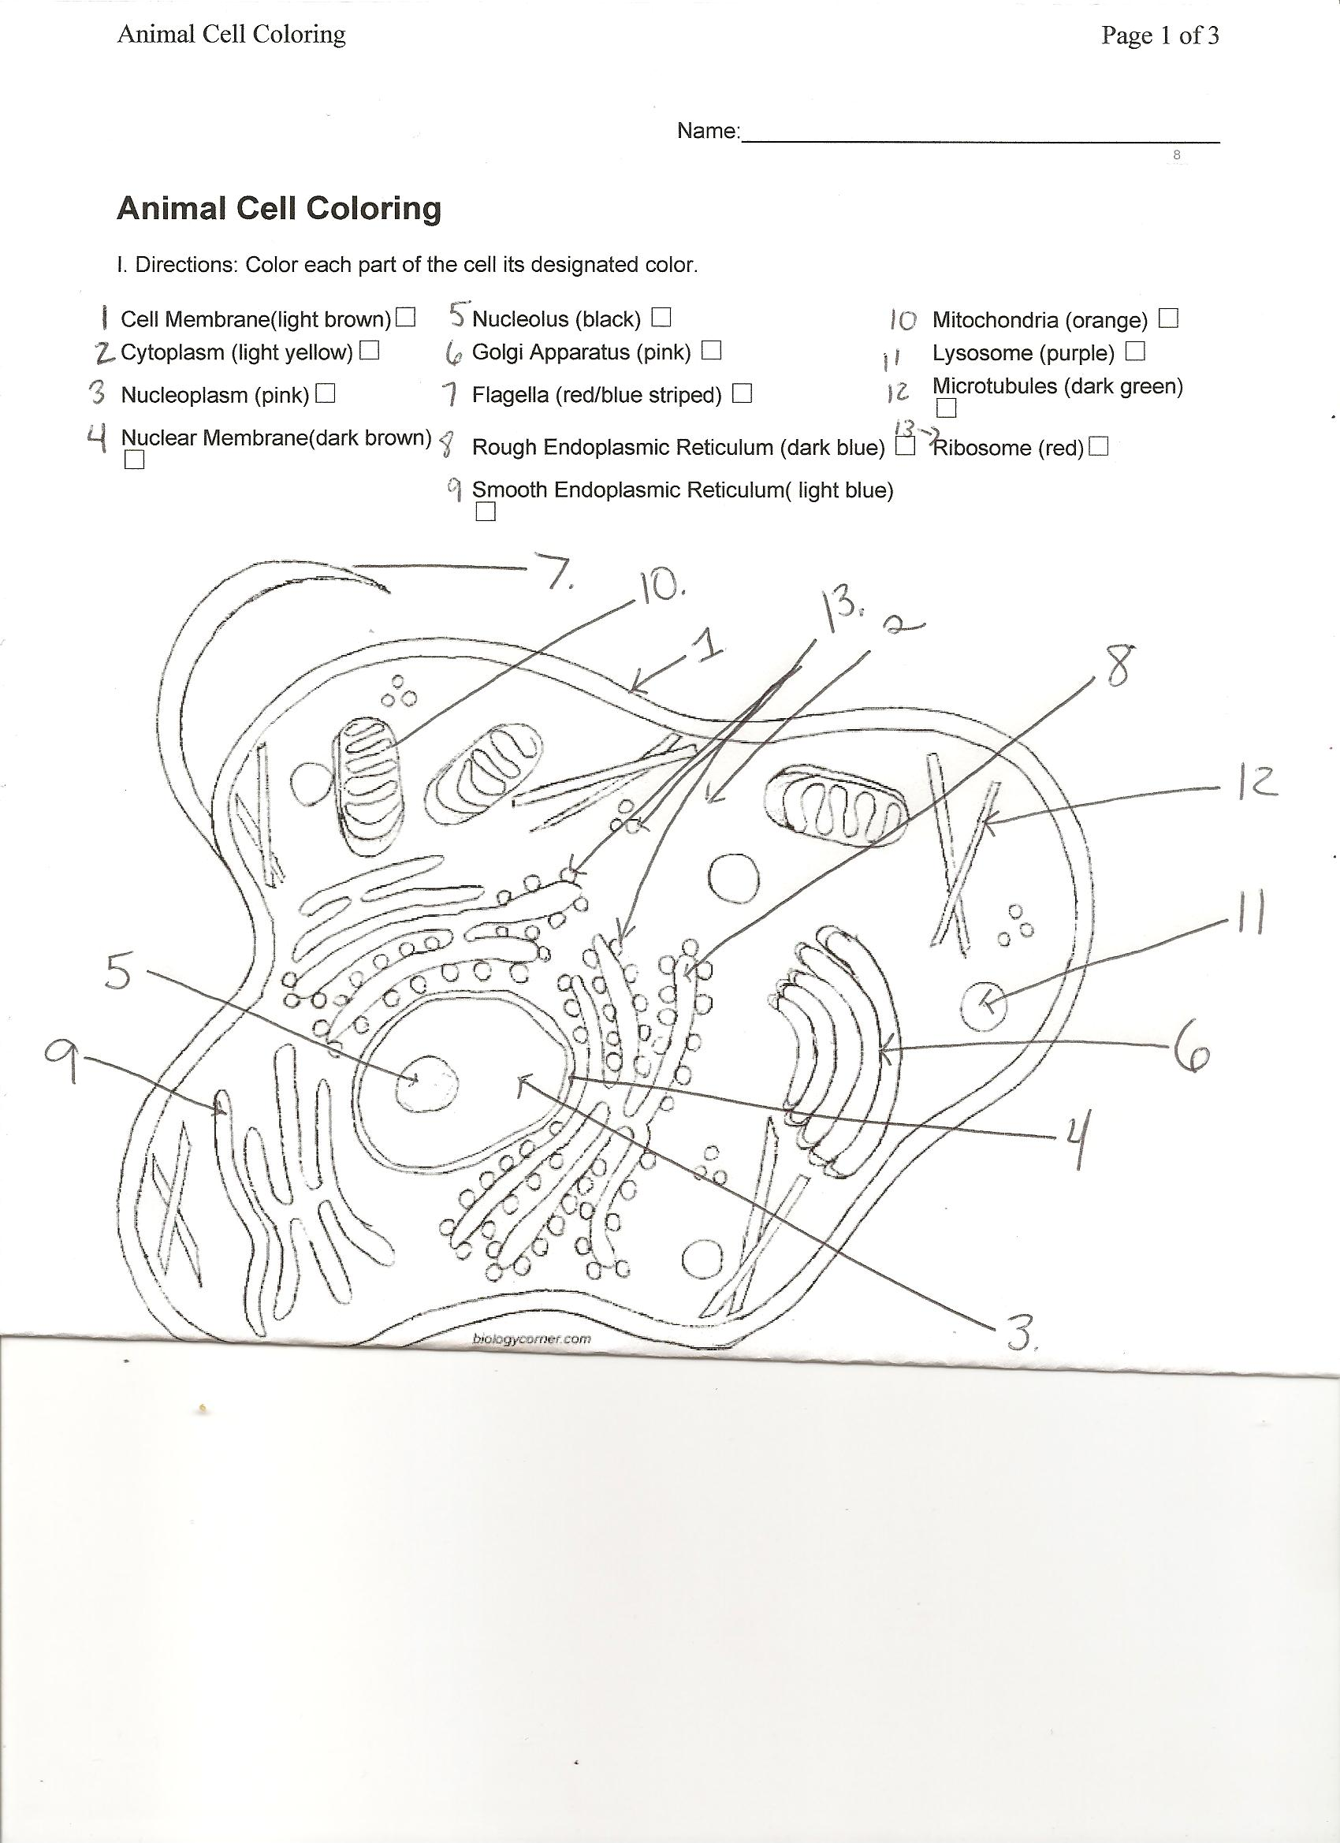

Define the following organelles:

1. Cell Membrane –
2. Cytoplasm –
3. Golgi Bodies –
4. Endoplasmic Reticulum –
5. Mitochondria –
6. Lysosome –
7. Ribosomes –
8. Vacuole –
9. Cell Wall –
10. Chloroplasts -