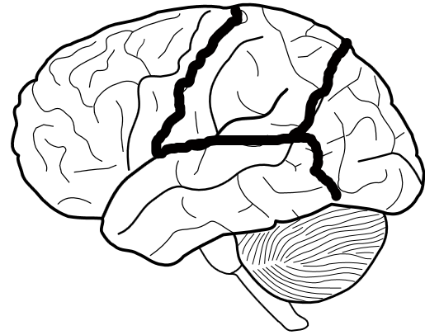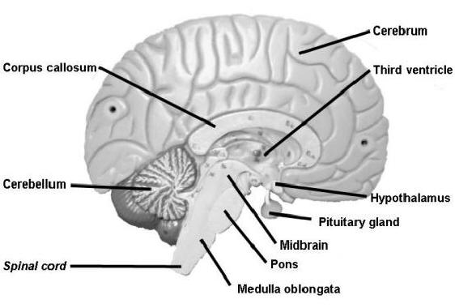

Brain stem

Temporal lobe

Frontal lobe

Cerebellum

Occipital Lobe

Parietal lobe