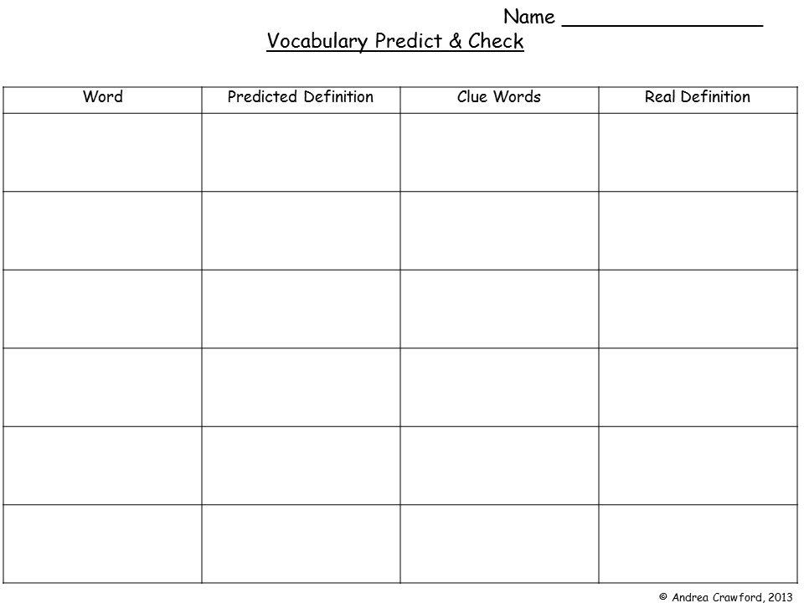

Why did you think this?

**Replication**

Cytokinesis

Chromosome

Mitosis

Interphase

Cell Cycle