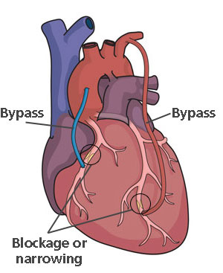
Heart Procedures
Heart Bypass Surgery
- Can be used to treat heart disease when your ____________ ____________________ are blocked.
- During bypass surgery, a ____________________ ________________ is removed or redirected from one area of the body and placed around the area/areas of __________________ in order to “____________” the blockages and restore _____________ _________________ to the heart muscle.
- The vessel that is used is called a ___________ and can come from your chest, legs, or your arms.
- During traditional heart bypass surgery , the heart is _________________ for about 30-90 minutes of the 4-5 hour surgery.
- While the heart is stopped, the patient is hooked up to a ______________ _____________ bypass machine that allows circulation of blood throughout your body during the surgery.
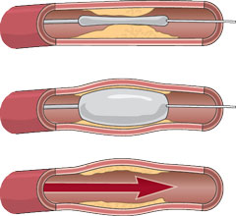
Angioplasty

- Angioplasty is a __________________ procedure that can be used to open blocked heart arteries.
- The procedure usually last about ____ -_____ hours.
- During balloon angioplasty , a specially designed catheter with a small balloon tip is guided to the point of narrowing in the artery. Once in place, the balloon is inflated to compress the fatty matter into the artery wall and stretch the artery open to ____________ the blood flow to the heart.
Arteriogram

- An arteriogram is an ____________ test that uses a special dye and camera ( fluoroscopy) to take pictures of the blood flow in an artery.
- An arteriogram can find a bulge in a blood vessel ( called and aneurysm) , show narrowing or a ________________ in a blood vessel that affects blood flow, or show if coronary artery disease is present and how bad it is.
STENTS
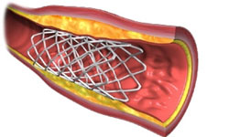
- A stent is a small, metal, mesh tube that acts as a scaffold to provide __________________ inside your coronary artery.
- A balloon catheter, placed over a guide wire, is used to insert the stent into the narrowed coronary artery. Once in place, the balloon tip is inflated and the stent _________________ to the size of the artery and holds it open. The balloon is then deflated and removed while the stent stays in place permanently.
- Stents are commonly used during other surgeries/procedures.

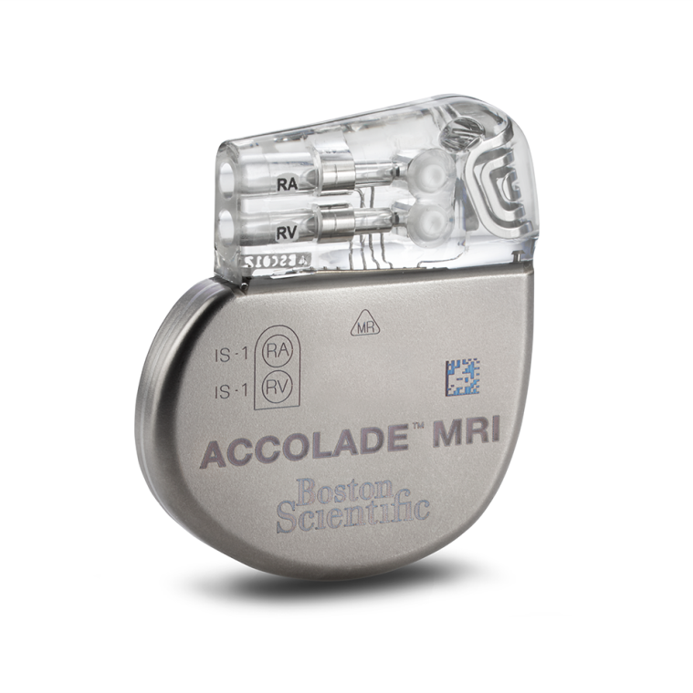
PACEMAKERS
- The normal , healthy heart has its own pacemaker that regulates the rate that the heart beats. However, some hearts don’t beat regularly.
- A pacemaker is a small device that sends __________________ impulses to the heart muscle to maintain a suitable heart rate and rhythm,.
- Pacemakers may last _______ to ____________ years and sometimes longer, depending on how often they are used.

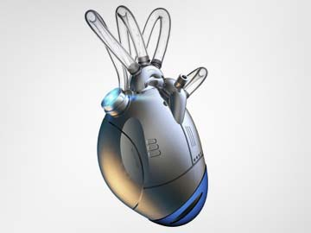
ARTIFICIAL HEARTS
- In some cases, heart disease may be so severe that the patient may not survive the wait for a donor heart.
- Medical scientists have developed ______________ __________ such as defibrillators, pacemakers, and artificial heart models that can keep the patient alive until a heart becomes available.
- In 1982, a team led by William DeVries of the University of Utah implanted the Jarvik -7 ( an artificial heart model) into a patient named Barney Clark. He surviv ed with the Jarvik-7 for ______________ days.
- Perhaps, someday , the artificial heart will become a realistic, _______________________ option for survival.

