MICROSCOPES: ( 55-57 in text)
- What is the difference between magnification and resolution
Magnification is making a object larger and resolution is the sharpness or clearness of an object

2. The eyepiece magnifies __10___X.
3. If the eyepiece is _10____X and the low objective is 10X , the total magnification of the 2 lenses together is ___100_____X.
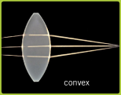
4. What type of lenses do microscopes contain to make the image larger? Draw a picture of this lens. Microscopes use a convex Lens to make the image larger
5. What do electron microscopes use instead of light to help produce an image? A beam of electrons.
6. What type of microscope did Robert Hooke use?
Compound
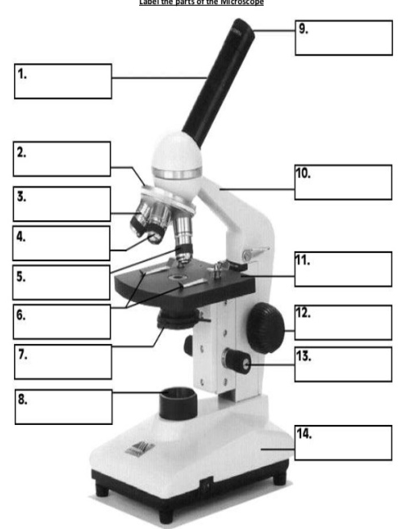
7. What did Robert Hooke observe? What did he call these tiny rooms? Robert Hooke observed tiny rooms that reminded him of the monk prayer cells. He called them cells.
8. What did Leeuwenhoek observe his “wee Beasties “ in? pond and rain water, teeth scrapings

9. Name the 3 parts of the cell theory. All living things are made of cells. 2. Cells are the basic unit of structure and function in living things.3. All cells come from other cells.

10. On the back - list the function of each of the following:
Cytoplasm, mitochondria, ribosome, nucleus, nucleolus, golgi body, endoplasmic reticulum, cell wall, cell membrane, vacuole, lysosome, & Chloroplasts
Cytoplasm - filler, mitochondria powerhouse site of respiration, ribosome protein factory, nucleus, director boss, golgi body packaging center and shipping, , endoplasmic reticulum highway of the cell for transportation, cell wall provides shape in plant cell, cell membrane holds cell together allows things in and out, vacuole storage, lysosome trash can of cell, & Chloroplasts gather sunlight in plant cell for photosynthesis

12. Who finally disproved spontaneous generation? Louis Pasteur

11. Also on the back write at least 5 sentences comparing and contrasting the plant and animal cell. Your answer should be in complete sentences.
Plant cells and animal cells both have a cell membrane, mitochondria, ER, lysosomes, nucleus, golgi, ribosomes, and cytoplasm. Plant cells have one large vacuole and animal cells have many vacuoles. Animal cells sometimes contain flagellum for movement. Plant cells contain a cell wall for support. Plant cells also have cholorplasts for photosynthesis

