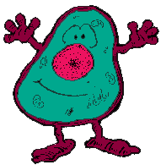
MICROSCOPES: ( 55-57 in text)
Name _______________________

Period_______________________
1. What is the difference between magnification and resolution

2. The eyepiece magnifies _____X.
3. If the eyepiece is _____X and the low objective is 10X , the total magnification of the 2 lenses together is ________X.
4. What type of lenses do microscopes contain to make the image larger? Draw a picture of this lens.

5. What do electron microscopes use instead of light to help produce an image?
6. What type of microscope did Robert Hooke use?

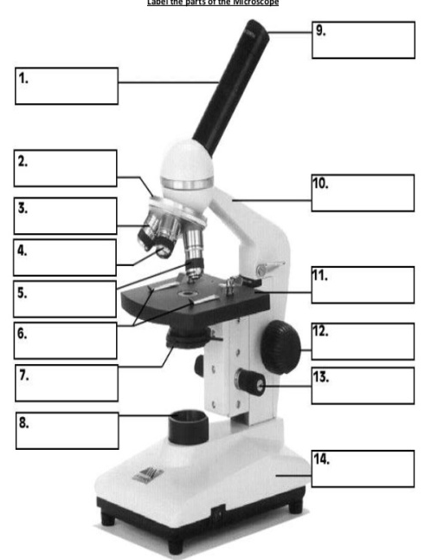
7. What did Robert Hooke observe? What did he call these tiny rooms?

8. What did Leeuwenhoek observe his “wee Beasties “ in?
9. Name the 3 parts of the cell theory.

10. On the back - list the function of each of the following:
Cytoplasm, mitochondria, ribosome, nucleus, nucleolus, golgi body, endoplasmic reticulum, cell wall, cell membrane, vacuole, lysosome, & Chloroplasts

11. Who finally disproved spontaneous generation?

12. Also on the back write at least 5 sentences comparing and contrasting the plant and animal cell. Your answer should be in complete sentences.

