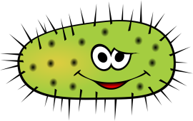
BACTERIA
Name_____________________________
Period_____________
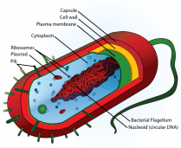
- Draw and label a bacterial cell

- What are the three shapes of bacteria? Bacilli ( rod), Cocci ( spherical), and Spirilla ( spiral).

- Bacteria can be autotrophic ( using sunlight or chemicals) or heterotrophic - which means they get food how? By eating or consuming other organisms.

- Bacteria can reproduce asexually by this process_binary fission___________, and sexually by this process _conjugation__________. Which one is best for the species in that it creates genetically different offspring ? _sexual reproduction ( conjugation in this case) _______________________.

- What are endospores? A type of cell covering that bacterial cells can go into if they experience extreme conditions . It is a sort of hibernation that they can go into for long periods of time ( centuries even) until conditions are favorable.

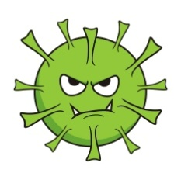
Viruses
- What is a virus? A tiny non living structure that contains DNA or RNA and has a protein coat.
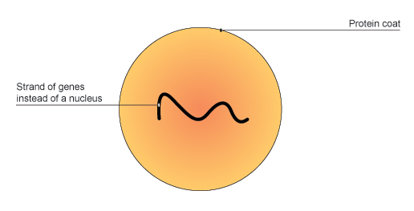

- Draw a picture of a virus and label

- Viruses are not alive because they must have a host. How are they like parasites?They are like parasites in that they cause harm to their host.

- Viruses can be active or hidden? What is the difference?Active viruses immediately attack and begin to “ boss” the cell forcing it to make copies of the virus. A Hidden virus will go into the cell and merge in with the DNA of the cell and “ hide out” for a while ( maybe even years) and then one day they will “pop out” and take over the cell. Then the virus begins to act like an active virus.

*** Make sure you can identify an active or hidden virus life cycle in a diagram ****

Protists
- Protists can be animal like which means they are heterotrophs___________ because they consume food, or they can be plant like ( algae) which means they areautotrophic_____________ because they make their own food.
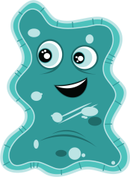
- Protists can move using a foot like structure called a _pseudopod________ like amoebas, tiny hairs called cilia__________ like paramecium, and whip like structures called __flagella_________ like euglenas.
- Some protists have a contractile vacuole – what does it do? A contractile vacuole acts as a pump or bladder to pump out extra water so the cell does not explode.
- Why are protists called the odds and ends kingdom? The kingdom Protista is composed of heterotrophs, autotrophs, single celled, multi cellular, organisms that don’t really fit into any other kingdom.

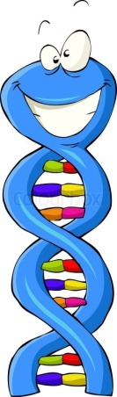
DNA/RNA/Protein Synthesis
- What is the shape of DNA ( official name? )__double helix__________________________.
- DNA is composed of 4 nitrogen bases, what are they? _adenine, guanine, cytosine, and thymine__________________________.
- In DNA , what pairs with adenine ? _thymine_________ with cytosine? guanine__________.
- What are the sides of the DNA ladder made of ? _ a sugar and a phosphate_________________________.
- What is the genetic code? __The genetic code is the order of the nitrogen bases__________________________.
- RNA is different from DNA in that it has __one_______strand and __uracil__________ instead of thymine.
- What is replication ? ___The process in which DNA makes a copy of itself._______________________________
- Where does protein synthesis take place ( where are proteins made) ? _Protein synthesis takes place in the ribosomes ( which are in the cytoplasm)…____________________________.
- What does mRNA do? Messenger RNA takes the message about which protein to make out of the nucleus ( because DNA is too fat) into the cytoplasm to the ribosome.

- What does tRNA do?Transfer RNA is like a taxi or an uber that goes to the ribosome and gets the message about which amino acid ( bead) to pick up to add to the growing protein chain (the necklace).

- If the protein is the necklace that is being made, what are the individual beads called ( what makes up a protein) ? amino acid________.

- A mutation is a change in a gene or chromosome. They can be helpful if they increase an organisms chance for survival. The can be harmful if they _decrease________ an organisms chance for survival.

GENETICS
- What type of plant did Gregor Mendel cross pollinate ? peas
- Mendel knew that the stamen produced the _sperm_____________ and the pistil produced the egg ( ovum)________ in plants.
- He found when he crossed purebred tall pea plants ( dominant) and purebred short pea plants ( recessive)he got all ___tall____________ pea plants in the F1 generation.
- We use capital letters to represent _dominance__________ and lowercase letters to represent __recessiveness_________________.
- Purebred is also know as homozygous__________________ , and heterozygous is also know as a _hybrid____________.
- Would TT be purebred or hybrid? _purebred___________ What about Tt? hybrid____________ What about tt? _purebred__________________.
- Is red hair a genotype or phenotype?
- Is RR a genotype or phenotype?
- What does meiosis create? Sex cells ( gametes) ( egg and sperm)______________
- The parental generation is known as the _P____ generation. The children of the P1 generation are know as the first filial or the F1____ generation. The children of the F1 generation are the second filial of the _F2_____ generation.
- What is a gene? A segment of DNA that codes for a specific trait.
- Different forms of a gene are called ___alleles_______________.
- What is a punnett square ? A genetic tool that allows you to see all the possibilities of offspring from a genetic cross

**** Be able to construct and analyze a Punnett Square*****
